TOBY’S ADVENTURE GAME

This work is licensed under a Creative Commons Attribution 4.0 International License. 

**GAME DESIGN DEVELOPMENT(GDD)**

Chilka Castro – sect. 00003

Madalina Turcan – sect. 00004

Jose Samayoa – sect. 00003

Nicolas Nguyen – sect. 00004

Tassia Camoes-Araujo

Game Programming 1

420-141-VA

22 November 2020

**Executive Summary:**

This game is inspired by the “**Crossy Road**” mobile game app. Our game consists of **three levels**, each one harder than the last one. We have a single character known as **Toby**, the dog. The overall objective of our game is to ensure that the dog makes it back home (located in level 3) safely without losing all his lives (3 initial lives); to ensure he gets back home to his owner alive or not kidnapped. In **level one**, we have enemies/obstacles which are traffic cones and cars. In **level two**, we have trains, cactus’, and a dog kidnapper/catcher, someone who catches dogs and sell them. In **level three**, the enemies/obstacles are cars, trucks, potholes/sewer holes, and bodies of water. The game mechanics to be used are the arrow keys which will allow the player to move Toby around. The win/lose conditions are, he starts off with 10000 points, within the number of lives given he must avoid all obstacles that reduce his points and if he encounters cars, trucks, potholes, trains, and the dog catcher/kidnapper, he loses 1000 pts. When Toby reaches home, he will get a dog treat from his owner which will increase the total score of the player. Throughout the game, the player can increase the points by picking up coins and increase Toby’s available lives by picking up hearts.

**World:**

* **Level 1:** City
* **Level 2:** Railroad (desert-themed)
* **Level 3:** Suburban (greener place)

**Main Character:**

* **Toby**, the dog

**Obstacles / Enemies:**

* **Dog Kidnapper/Catcher**
* Vehicles: **Cars**, **Trucks**, **Trains**
* Other objects**: Traffic Coins**, **Cactus**, **Bodies of water**, **Potholes/Sewer hole**

**Allies/ Good objects:**

* **Toby’s Owner -** gives Toby Dog Treat when he returns home
* **Dog Treat –** given by Toby’s owner
* **Coins** and **Hearts**

**Characters Goals:**

* **Main goal**: Toby must return home safely to his owner (found on **Level 3**).
* Do not get hit by any form of vehicle: cars, trucks, and trains
* Do not get captured by the Dog Catcher/ Dog Kidnapper.
* Avoid cactus, holes, traffic cones and bodies of water.
* Pick up coins, hearts and a dog treat.

**Game Win/Lose Conditions:**

* **Win:** If Toby returns home safely; player only wins if he finishes the three levels.
* **Lose:** If Toby has no more remaining lives available because of the enemies and obstacles.

**Game Point System:**

* Initial Points: **10000 pts.**
* Initial Lives: **3 lives (**can be increased by picking up hearts**)**

**Point Deduction** (Interaction):

* **Vehicles: Cars, Truck and Trains: - 1000 pts**
* **Dog Kidnapper/Catcher: -1000 pts.**
* **Potholes/Sewer Holes: -1000 pts.**

**Other deductions:**

* **Orange traffic cones: -100 pts.**
* **Bodies of water: - 200 pts.**
* **Cactus: -150 pts.**

**Increase Points:**

* **Coins: 150 pts.**
* **Dog Treat: 200 pts.**

**Increase Lives:**

* **Heart: 1 life**

**User Interface Mock-Ups:**

**Level 1: City-style**

Enemies/Obstacles: **Cars, Traffic Cones**

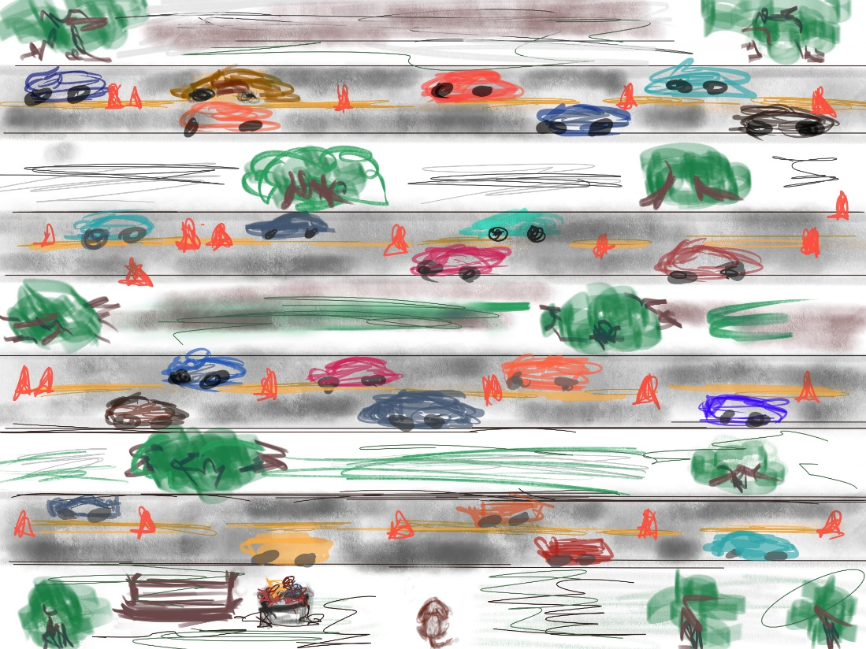

**Using Paint**

**Level 2: Desert-Style**

Enemies/Obstacles: **Cactus**, **Trains**, **Dog Catcher/Kidnapper**

Point Boost: **Coins**

Life Boost: **Heart**

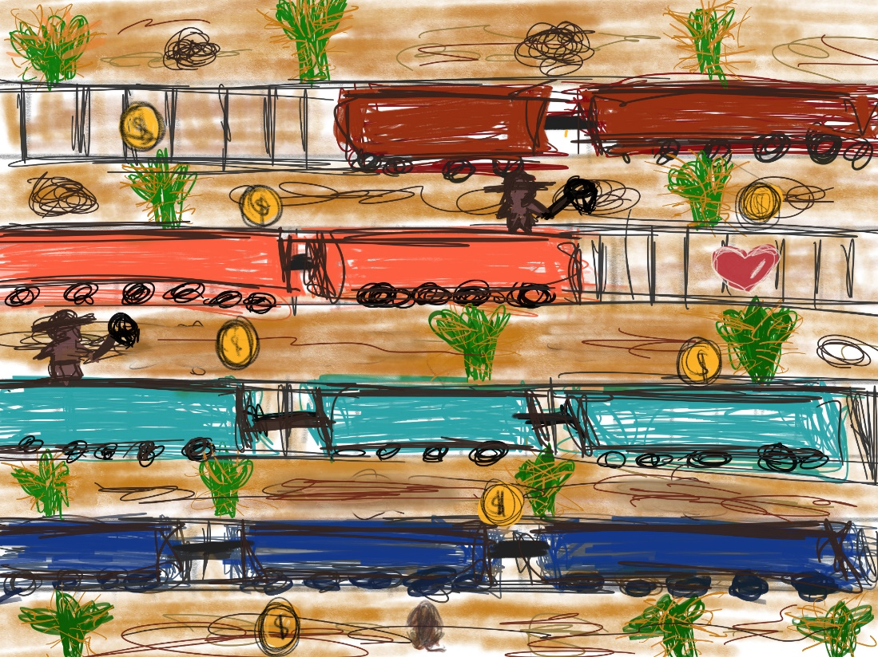

**Using GIMP**

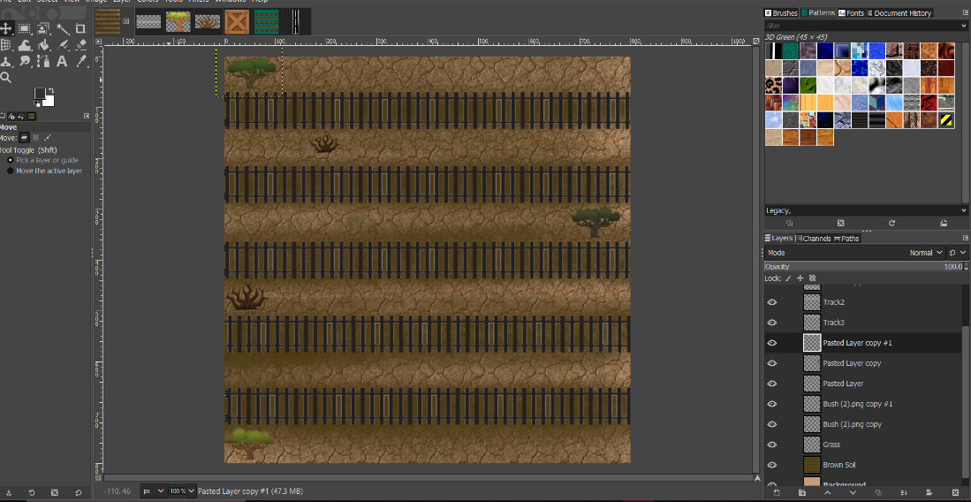

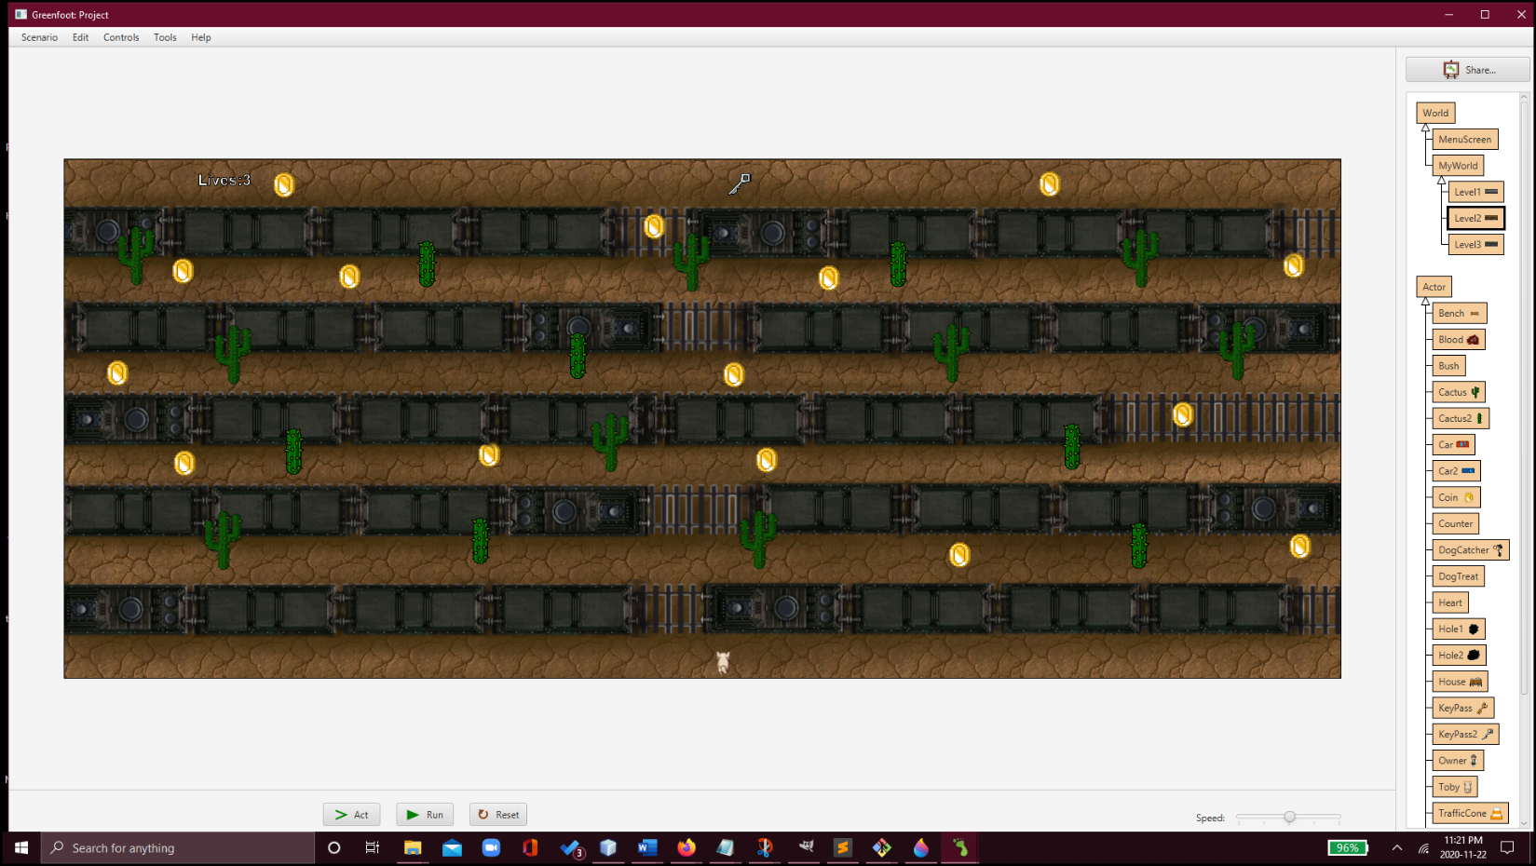

**Level 3:**

Enemies/Obstacles: **Bodies of water**, **Trucks**, **Cars**

Point Boost: **Coins**, **Toby’s Owner (gives him dog treat), Potholes/Sewer Holes**

Life Boost: **Heart**

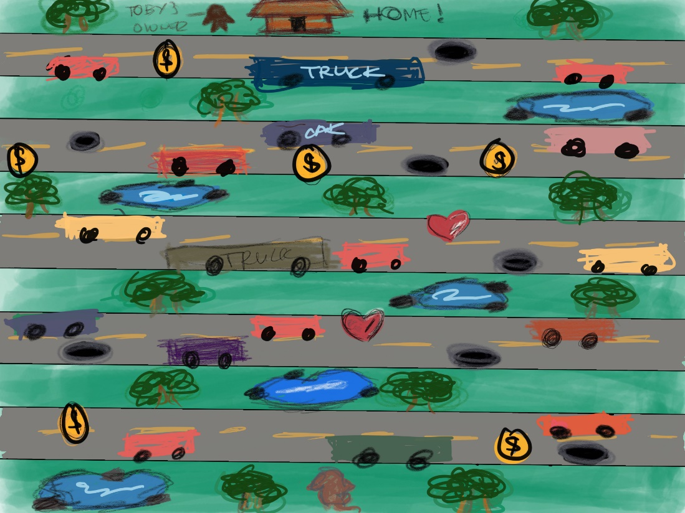

**Using GIMP**

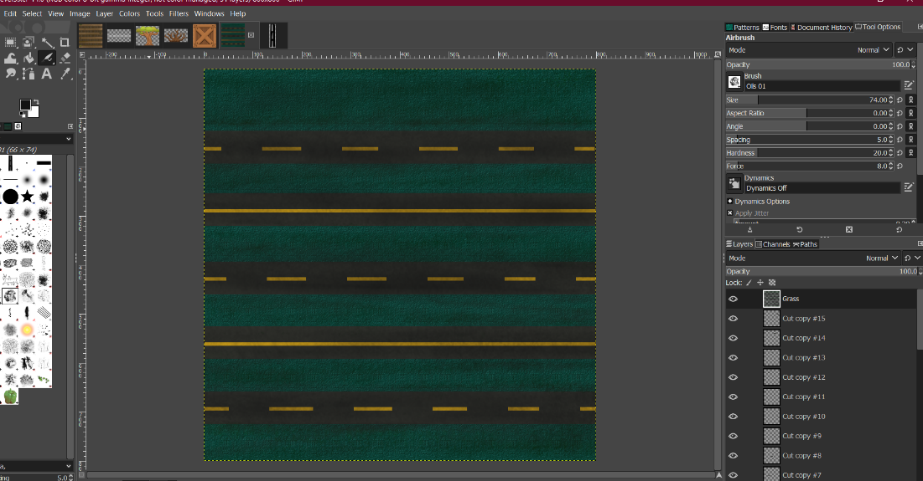

**Controls:**

**Arrow keys** (up, down, right, left):

* + **“Up”** Key allows the dog to move forward
  + **“Down”** Key allows the dog to move backward
  + **“Left”** Key allows the dog to move the left
  + **“Right”** Key allows the dog to move to the right

**Developer Roles:**

* **Chilka:** Project Manager, Game Developer, Level Designer
* **Madalina:** Project Manager, Game Developer, Level Designer
* **José:** Game Developer, Sounds
* **Nicolas:** Game Developer, Sounds

**Schedule of releases:**

Try to list all the tasks involved in the development, each feature you want delivered, and distribute those among the versions:

* **11/15: Prototype** 
  + To check if the game works or if our ideas are applicable to the game.
  + Using placeholder images/assets as temporary objects on the game, which can be changed later.
  + **Level 1** **Distribution**– idea and game mechanics testing
* **11/22: First playable**
  + To change the placeholder assets with higher quality images.
  + Do Level 1, Level 2 and Level 3.
* **11/29: Pre-Alpha** 
  + Possible major improvements to change includes code, graphics, objects, sounds, etc.
  + Possibility of more objects to include in the game to make it more realistic and appealing.
* **12/06: Alpha**
  + To test the game several times and to have others test the game. Also, to get some comments/feedbacks from others so that we could do some mini improvements.
* **12/10:** **Gold Master** – Game is ready to be presented.

**Sources:**

* **Dog :** [**https://forums.rpgmakerweb.com/index.php?threads/whtdragons-animals-and-running-horses-now-with-more-dragons.53552/**](https://forums.rpgmakerweb.com/index.php?threads/whtdragons-animals-and-running-horses-now-with-more-dragons.53552/)
* **Train track:** [**http://www.pngmart.com/image/22957**](http://www.pngmart.com/image/22957)
* **Cars and Truck**[:  **https://opengameart.org/content/top-view-car-truck-sprites**](https://eduvaniercollegeqc-my.sharepoint.com/personal/2078214_edu_vaniercollege_qc_ca/Documents/:%20%20https:/opengameart.org/content/top-view-car-truck-sprites)
* **Cactus:** Barbara Rivera, Casper Nilsson, Johann CHARLOT, Chris Phillips, Team River Fox, and Lanea Zimmerman (AKA Sharm). <https://opengameart.org/content/lpc-plant-repack>
* **Dognapper:**
* **Owner:**
* **Traffic Cones:**
* **Holes:**
* **House:** [**https://opengameart.org/content/top-down-rpg-mockup-scene**](https://opengameart.org/content/top-down-rpg-mockup-scene)
* **Train: author:** [**https://opengameart.org/users/chabull**](https://opengameart.org/users/chabull)
* **Bodies of Water:**
* **Bench:**

**Sounds:**

* https://freesound.org/people/markedit/sounds/157873/